Q-1) Write a SELECT statement that returns four columns from the Invoices table: InvoiceNumber, InvoiceDate, InvoiceDueDate, and InvoiceTotal. Use AP database.

Sol:

SELECT InvoiceNumber, InvoiceDate, InvoicDueDate, InvoiceTotal

FROM Invoices;

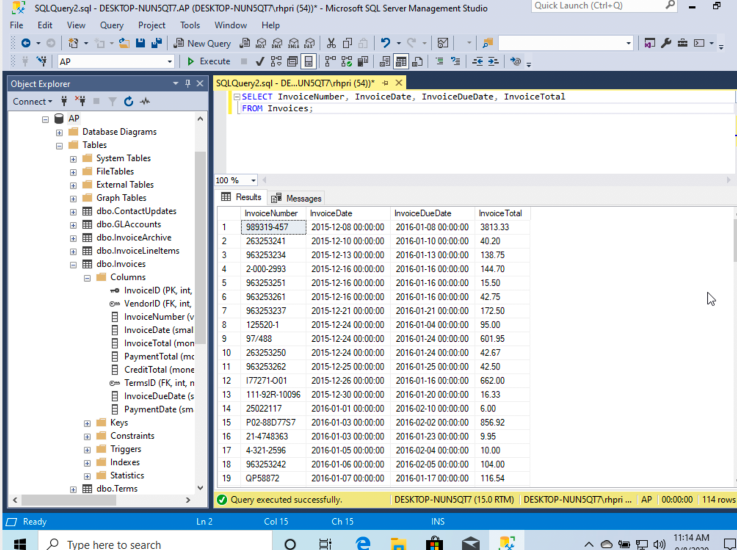

Comments: The query requires us to display 4 columns from the Customers table hence I used select statement which displays the columns from the specified table using the column names.

Q-2) Write a SELECT statement that returns three columns from the Invoices table, named Number, Total, and Credits:Number Column alias for the InvoiceNumber column Total Column alias for the InvoiceTotal column Credits Column alias for the sum of the PaymentTotal and CreditTotal columnsAnd filter for invoices with an InvoiceTotal that’s less or equal to $300. Use AP database.

Sol:

SELECT InvoiceNumber AS Number, InvoiceTotal AS Total, PaymentTotal + CreditTotal AS Credits

FROM Invoices

WHERE InvoiceTotal <= 300;

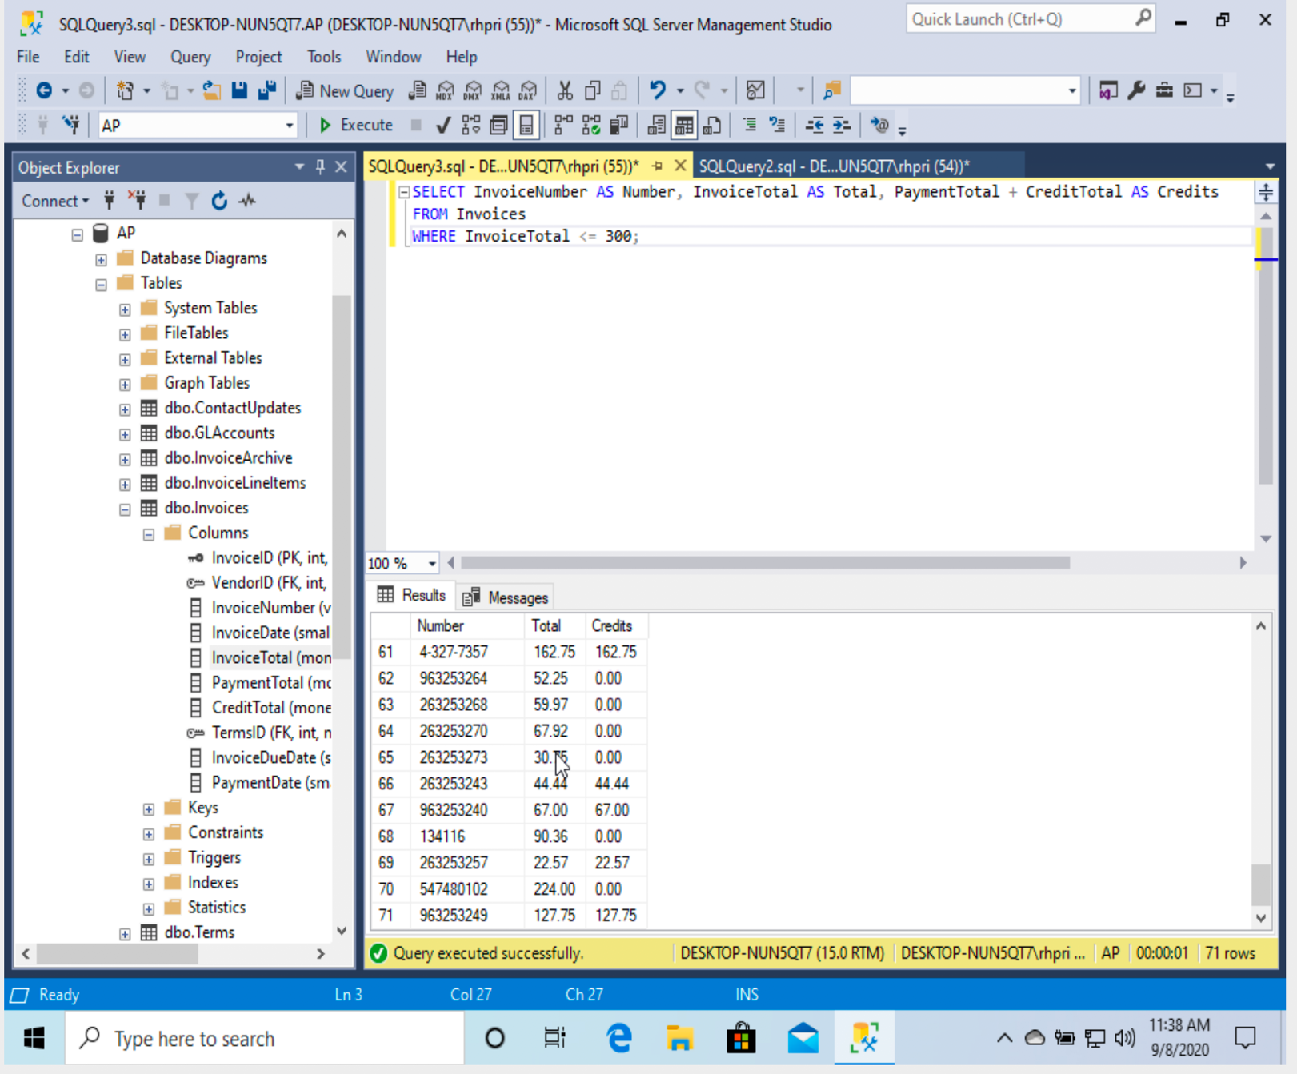

Comments:The query requires to display the InvoiceNumber InvoiceTotal and a sum of paymenttotal and Credittotal as Credits, for that I used the CONCAT in the query using select displayed the columns and filtered the columns using the where clause .

Q-3) Write a SELECT statement that returns one column from the Vendors table named “Full Name”. Create this column from the VendorContactFName and VendorContactLName columns. Format it as follows: last name, comma, first name. Sort the result set by last name from “Z-A”. Use AP database.

Sol:

SELECT VendorContactLName + ',' + VendorContactFName AS [Full Name]

FROM Vendors

ORDER BY VendorContactLName DESC;

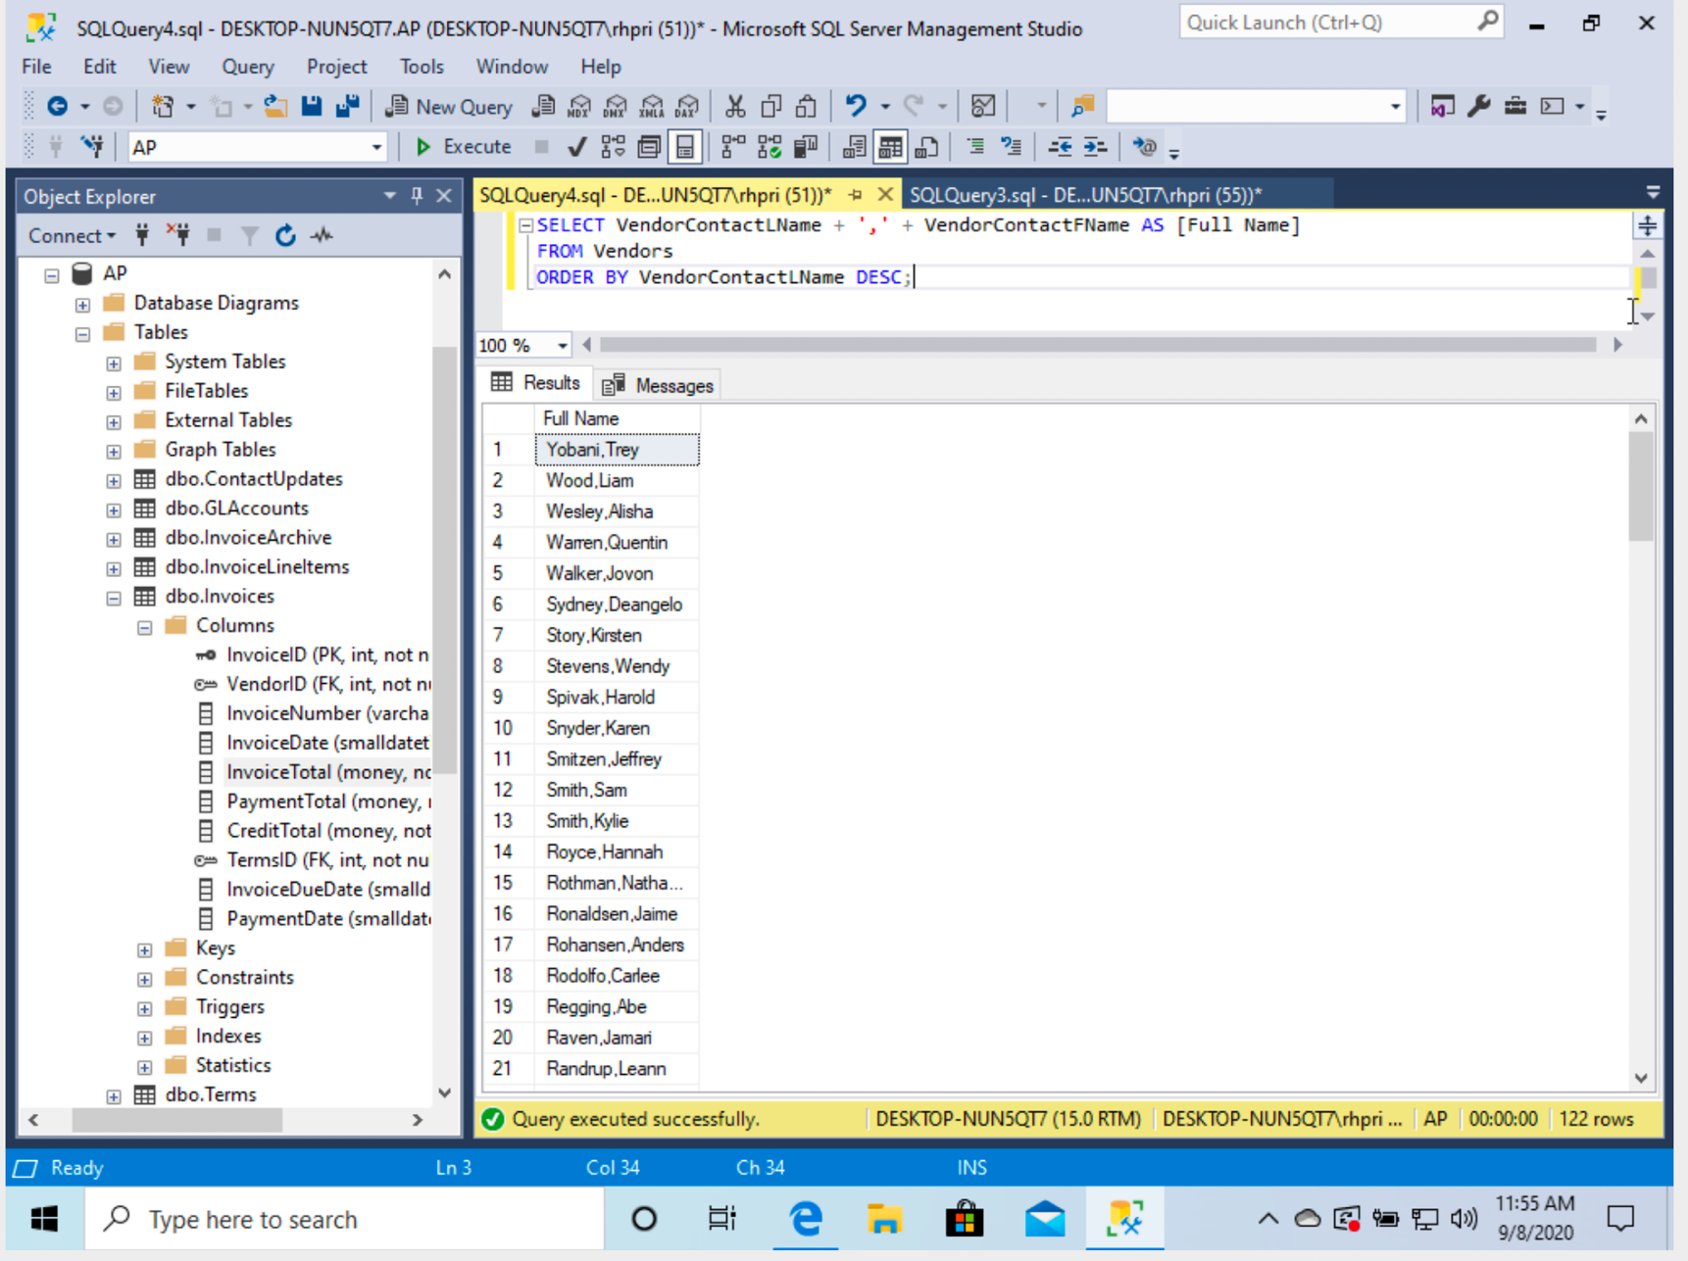

Comments:The query requires us to select a few columns from the table and print them together so I have used select statement with ‘+’ concat operator to display the results in required format

Q-4) Write a SELECT statement that determines whether the PaymentDate column of the Invoices table has any valid values. To be valid, PaymentDate must be a null value if there is a balance due and a non-null value of there is no balance due. Code a compound condition in the WHERE clause that tests for these conditions. (Balance: InvoiceTotal minus the sum of PaymentTotal and CreditTotal). Use AP database.

Sol:

SELECT \*FROM Invoices

WHERE ((InvoiceTotal - PaymentTotal + CreditTotal <= 0) AND PaymentDate IS NOT NULL)

OR

((InvoiceTotal - PaymentTotal + CreditTotal > 0) AND PaymentDate IS NULL)

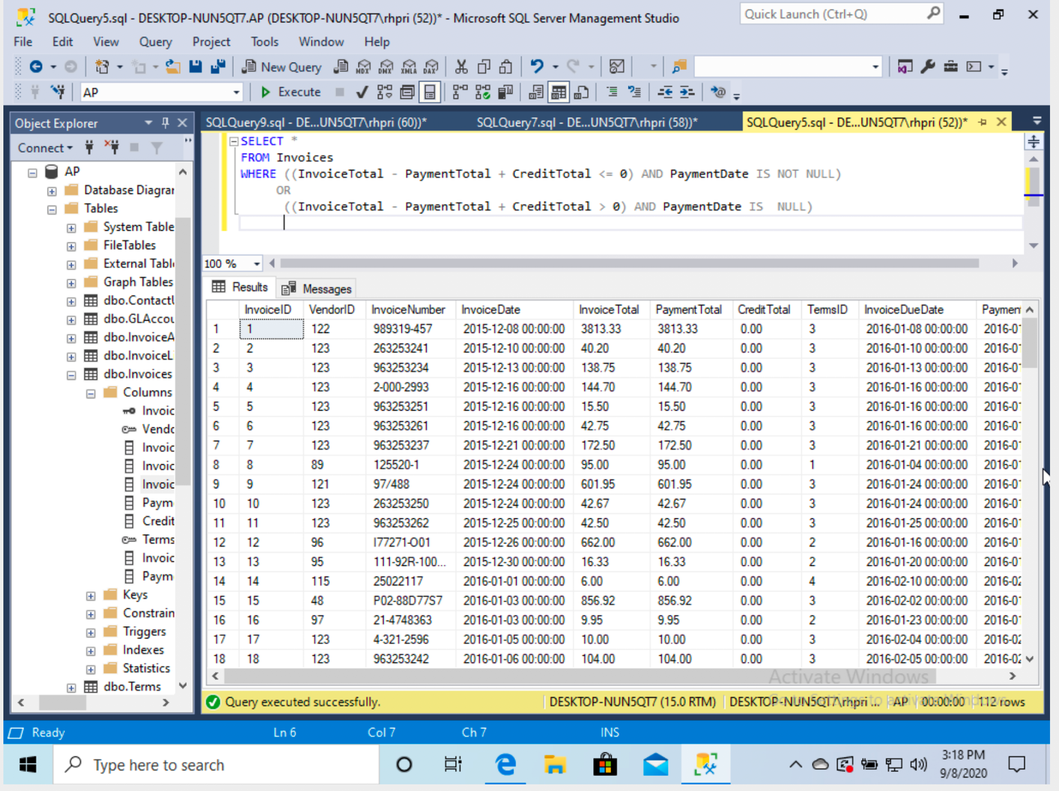

Comments: The query requires us to calculate the balance due for the payDate in the where clause .

Q-5) Write a SELECT statement that returns five columns: VendorName, VendorCity, VendorZipCode, DefaultAccountNo and AccountDescription from the Vendors table and GLAccounts table. The result set should have one row for each vendor, with the city, zipcode, account number and account description for that vendor’s default account number. And filter for Vendors whose AccountDescription is ‘Other Equipment’ and sort the result set by VendorCity from Z to A. Use AP database.

Sol:

SELECT VendorName, VendorCity, VendorZipCode, DefaultAccountNo, AccountDescription

FROM Vendors LEFT JOIN GLAccounts

ON Vendors.DefaultAccountNo = GLAccounts.AccountNo

WHERE AccountDescription = 'Other Equipment'

ORDER BY VendorCity DESC;

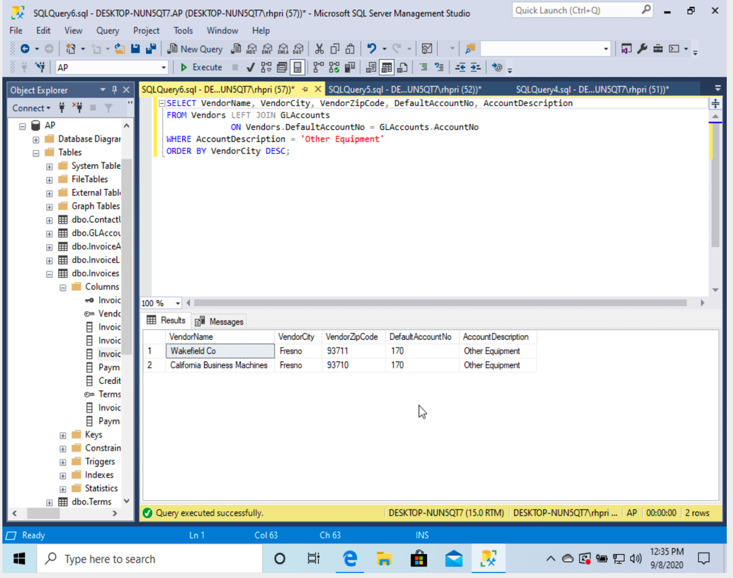

Comments:I needed information from two different tables so I performed a join on the tables using the commont column defaultaccount number and later filtered using a where clause .Sorting has been done in alphabetical descending order.

Q-6) Write a SELECT statement that returns two columns from ContactUpdates table: FirstName and Full Name (A concatenation of FirstName and LastName, with a comma in between). The result set should have one row for each vendor whose contact has the same last name as another vendor’s contact. Sort the final result set by FirstName from A to Z. Are there such vendors? Use AP database.

Sol:

SELECT DISTINCT c1.FirstName, c1.FirstName + ',' + c1.LastName AS 'Full Name'

FROM ContactUpdates AS c1 JOIN ContactUpdates AS c2

ON (c1.VendorID <> c2.VendorID) AND (c1.LastName = c2.LastName)

ORDER BY c1.FirstName ASC;

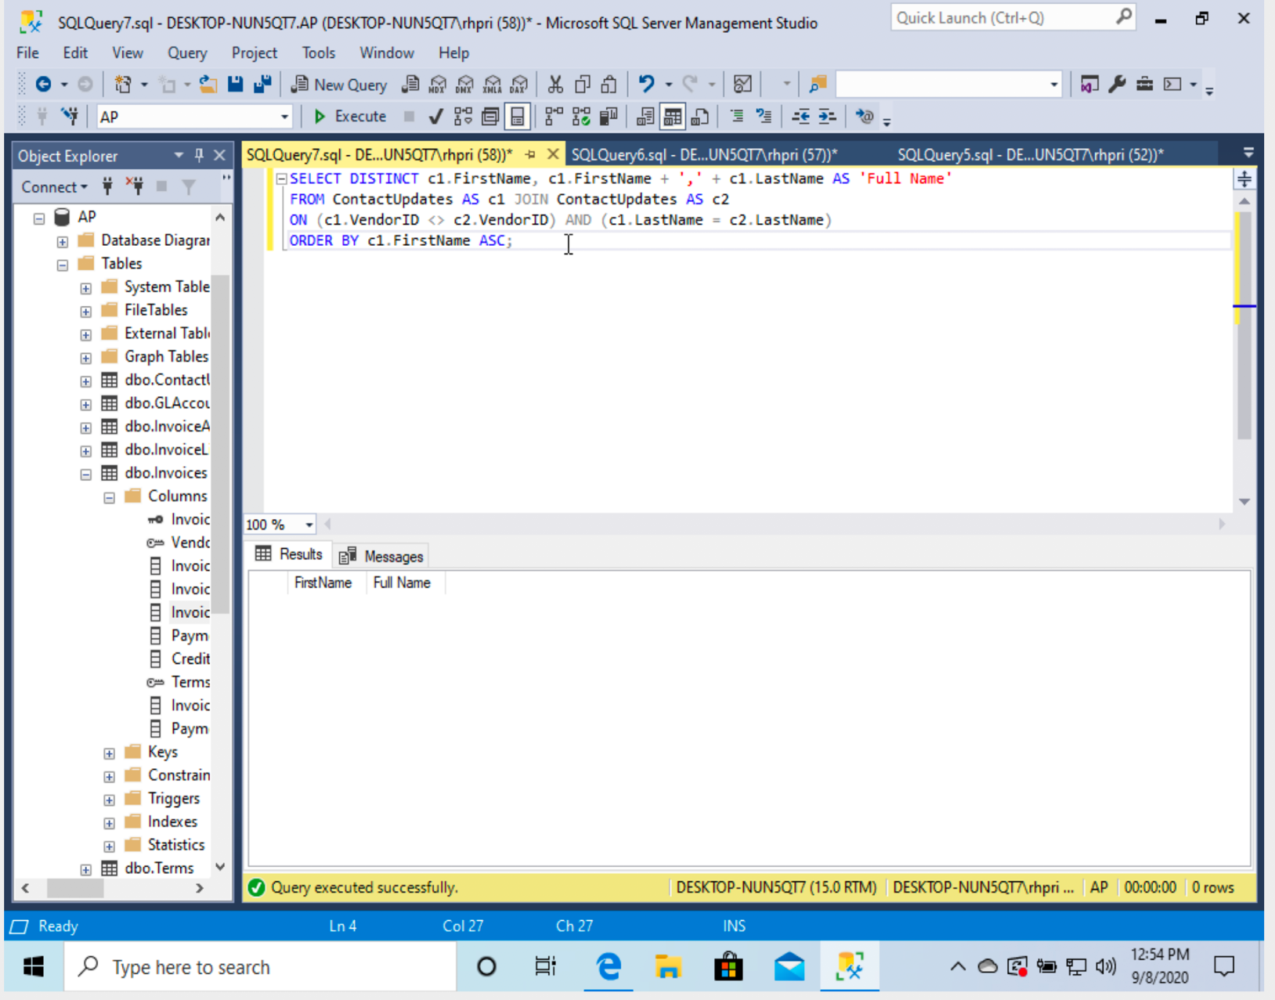b) There are no such vendors.

Comments: Query requires us to check for common last names from vendor contacts. I used concat ‘+’ to show first name and last name as full name and later checked for matching last names in the table. Sorting has been done in alphabetical ascending order. The output shows there are no such contacts.

Q-7) Use the UNION operator to generate a result set consisting of two columns from the Vendors table: VendorName and VendorState. If the vendor is in California, the VendorState value should be “CA”; otherwise, the vendorState value should be “Not in CA”. Sort the final result set by VendorName from A to Z. Use AP database.

Sol:

SELECT VendorName, VendorState

FROM Vendors

WHERE VendorState = 'CA'

UNION

SELECT VendorName, 'Not in CA'

FROM Vendors

WHERE VendorState <> 'CA'

ORDER BY VendorName ASC;

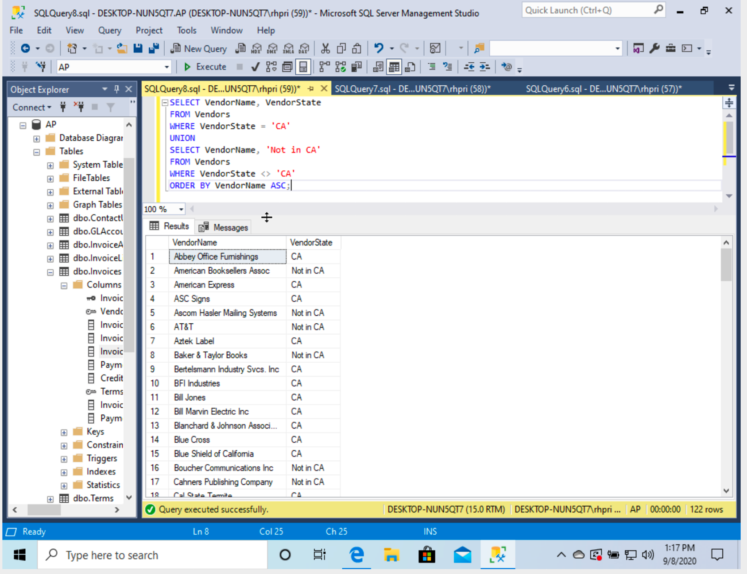

Comments: created a table with vendorname and vendorstate columns. checked if vendor state is California and used a union operator to add rows where vendorstate is not California. Sorted rows in alphabetical ascending order

Q-8) Write a SELECT statement that returns a column from the OrderDetails table: ItemID. The result set should have one row for each item whose order was placed but not yet shipped (i.e. ShippedDate in Orders table has null value). Use ProductOrders database.

Sol:

  SELECT OrderDetails.ItemID

FROM Orders LEFT JOIN OrderDetails

ON OrderDetails.OrderID = Orders.OrderID

WHERE Orders.ShippedDate IS NULL;

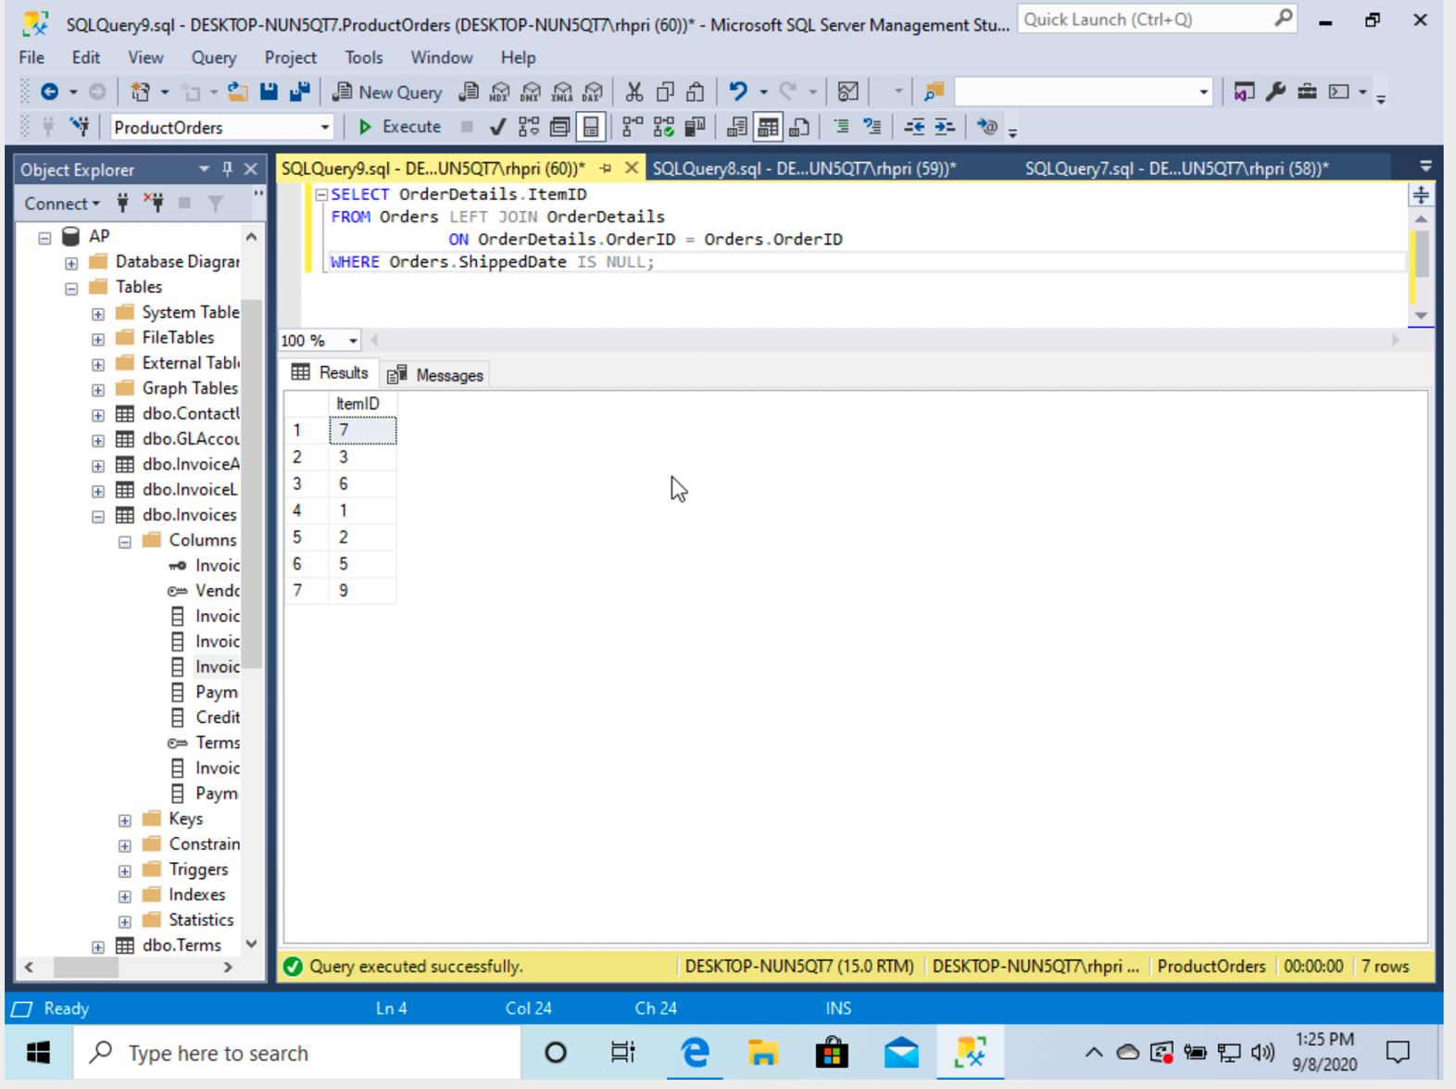

Comments: used left join to join order and orderdetails table so as to check for the value in shippedate along with printing itemid which is a column of orderdetails.checked if the shipped date is null using where clause.